# Project Setup

Tech Stack: ROR + MYSQL + (Typescript + Nextjs)

Parent Client: RIT (software company Japan)

Child Client: OsakaMetro (train station)

* A-sha (Construction Mngt)

### BE

1. Clone backend repo git@github.com:RIT-Inc-Dev/om-bldg-api.git
2. Run ***docker-compose up -d --build*** to build the containers
   1. Db, app, redis and worker should be present if you check using ***docker ps***
   2. It will automatically build the app and execute migrate and seed command
   3. Open db manager and input the following credentials (ex. workbench)
      1. Host: 127.0.0.1
      2. Username and password is empty
      3. Database Name: om_bldg_development
      4. Port: 3306
3. Check <http://localhost:3000/> to see if it’s successfully serve
4. Additional Notes
   1. Get inside docker container
      1. ***docker exec -it <container-id> bash***
   2. Check logs inside docker container
      1. ***docker logs -f <container-id>***

### FE

1. Clone frontend repo [git@github.com](mailto:git@github.com):RIT-Inc-Dev/om-bldg-client.git
2. Run ***npm install*** to install node_modules
3. Run ***npm run dev***
4. Check [http://localhost:8080/](http://localhost:3000/) to see if it’s successfully serve
5. Login using the credentials that can be found in om-bldg-api/db/seeds.rb
   1. Example acct
      1. email: [test@example.com](mailto:test@example.com)
      2. pass: test

# Mail Setup

1. Configure your mailtrap
2. Go to your inbox settings
3. Under integrations choose Ruby on Rails
4. Copy the following credentials to this file
   1. It should look like this.

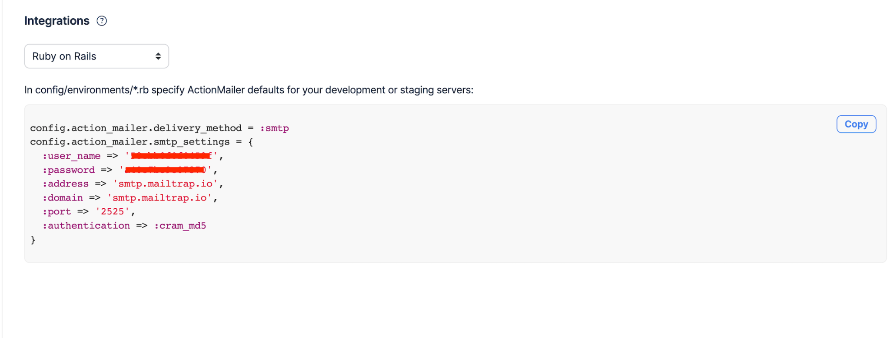

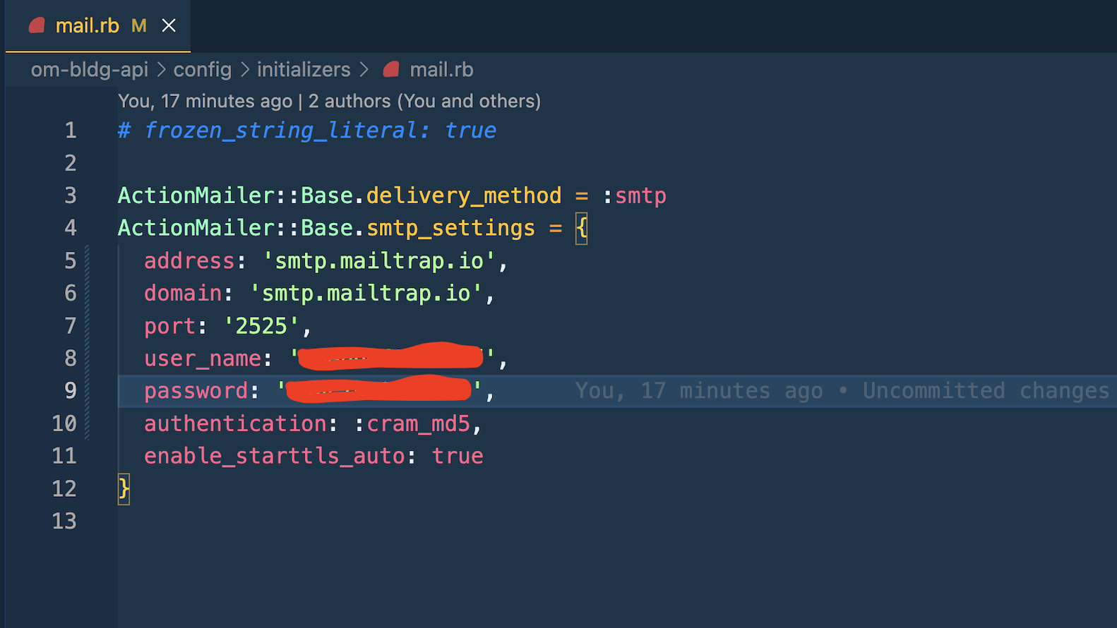

1. For testing purposes
   1. Docker restart or down and up for changes to take effect.
   2. Create a new Design.
   3. Make use the target user is an Asset Manager or 資産管理担当
   4. For more information, Check the create method in the file ***om-bldg-api/app/controllers/designs_controller.rb***
2. Set mail.rb file to assume-unchanged so git won’t tract it’s changes
   1. Run this command ***git update-index --assume-unchanged "config/initializers/mail.rb"***

# BE Linting

1. Go to docker app container
2. Refer to the docker here on how to fix lint errors
   1. <https://rubocop.org/>

# BE Unit Testing

1. Go to docker app container
   1. specific folder (all)
      1. ***ruby -I test***
   2. specific file
      1. ***ruby -I test test/controllers/construction_statements_controller_test.rb***
   3. specific method
      1. ***ruby -I test test/unit/my_model_test.rb -n test_invalid_with_bad_attributes***